**诚信 ·合作 ·共赢**

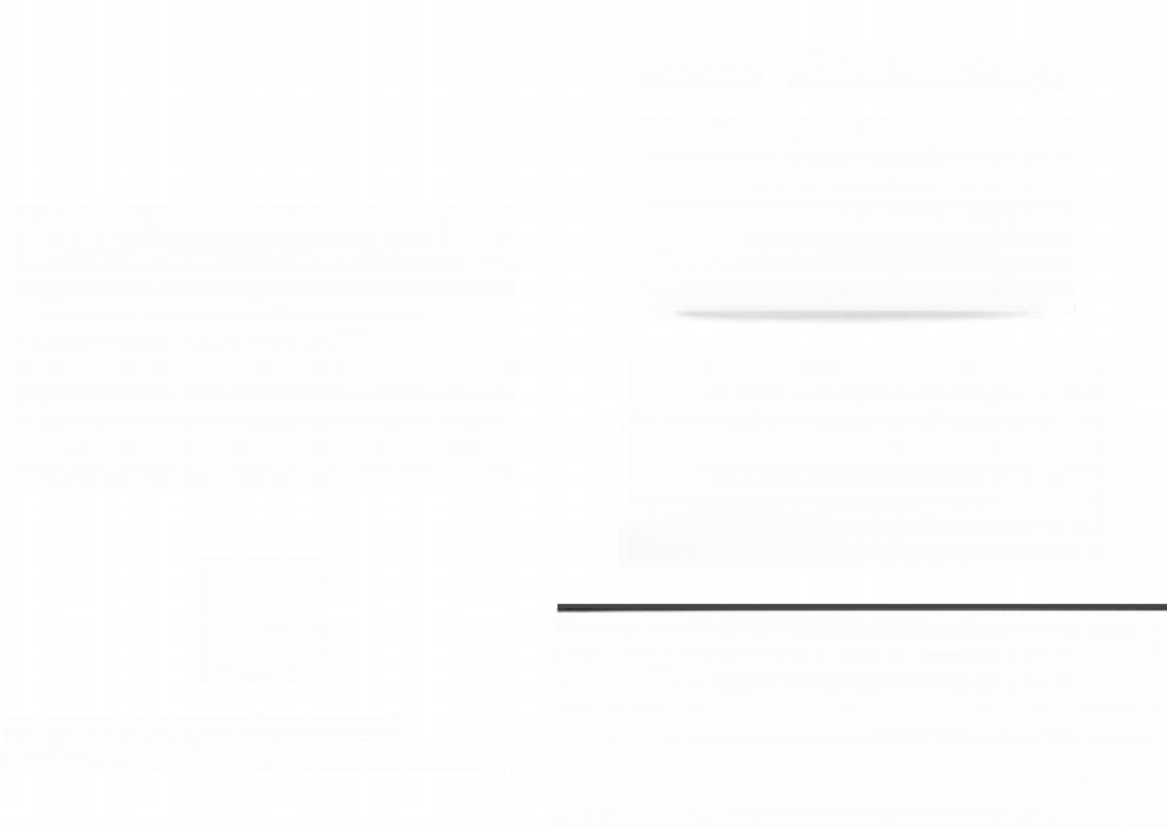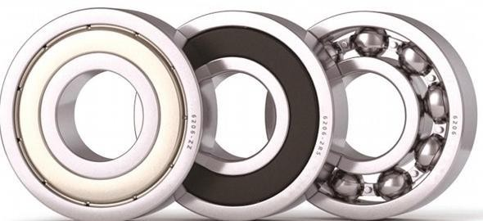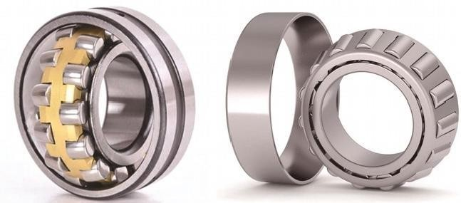

手机：13869562017 电话：0635-2321009

**山东盈佳轴承制造有限公司**

Shandong Yingjia Bearing Manufacturing Co,Ltd

地址：山东省临清市唐元工业园李官寨村委会往东100米路南

# 公司简介

### INTRODUCTION

山东盈佳轴承制造有限公司是一家专业生产圆锥滚子轴承和深沟球轴承、汽车专用轴承的厂家。

公司占地2000 多平方米， 现有职工50 余人， 其中专业技术人员10 多人， 拥有先进的切入式自动磨加工生产线8 条， 年产轴承100 多万套。产品出口欧洲国家和中东地区，我们还是一汽集团的轴承配套单位。

可靠的质量，有竞争力的价格，优质的服务始终是我们企业追求的目标。

# 企业荣誉

CORPORATE HONORS

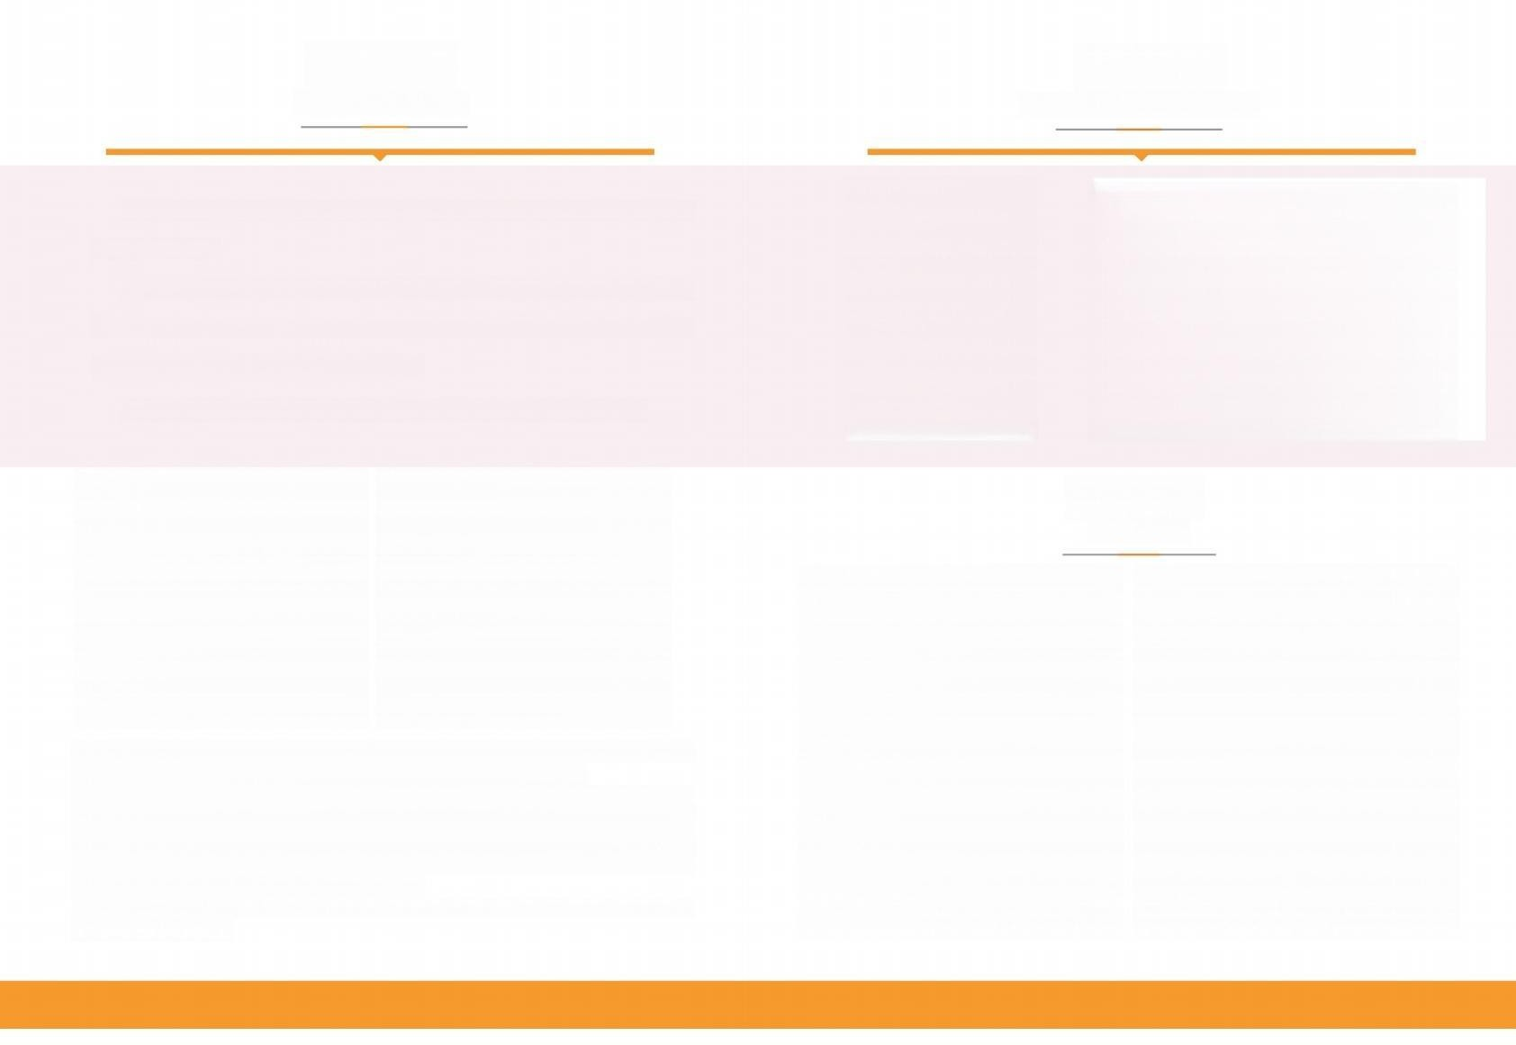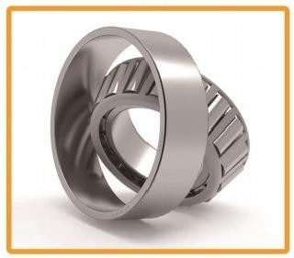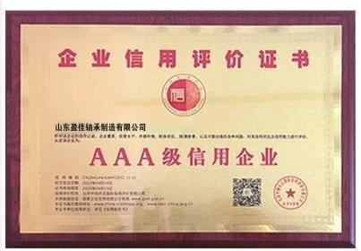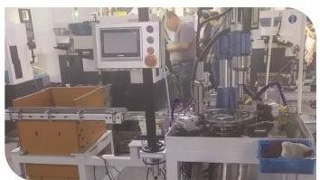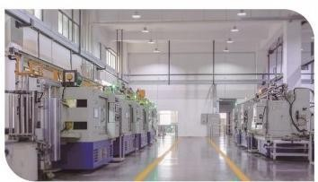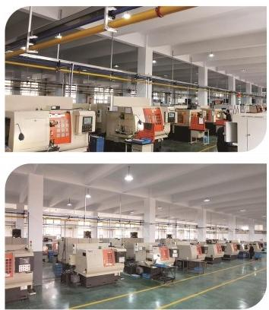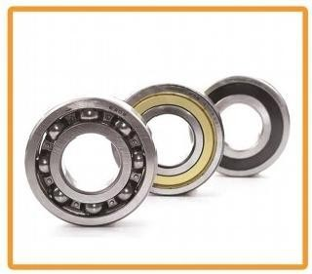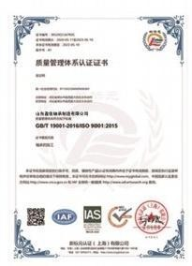

# 厂内一角

### IN-PLANT

Shandong Yingjia Bearing ManufacturingCo.,Ltd.is a professional manufacturer of tapered roller bearings,deep groove ball bearings,and automotivespecial bearings.

The company covers an area ofover 2000 square meters and currently has more than 50 em- ployees,including more than 10 professional and technical personnel.It has 8 advanced cut- ting in automatic grinding production lines and an annual output of over 1 million sets of bearings.Our products are exported to European countries and the Middle East region,and we are also a bearing supporting unit of FAW Group.

Reliable quality,competitive prices,and high-quality service have always been the goals pur- sued by our enterprise

## 深沟球轴承

deep groove ball bearing

## 圆锥滚子轴承

Tapered roller bearing

#### 深沟球轴承是滚动轴承中最具有代表性的结构，用途广泛。该类轴承摩擦距小，最适合于高速旋转，低噪音、低震动的场合，此类轴承有开式和封闭式多种变形结构。

Deep groove ball bearings are the most representativestructure among rolling bearings and have a wide range of applications.This type of bearing has a small friction distance and is most suitable for high-speed rotation, low noise,and low vibration situations.There are various deformation structuresof open and closed types for this type of bearing。

#### 圆锥滚子轴承主要用于承受以径向负荷为主的径向、轴向联合负荷。轴承的内组件和外圈可以分离，方便了安装和拆卸。

**轴承的轴向承载能力由接触角决定，角越大，轴向承载力越大**。

Tapered roller bearings are mainly used to withstand combined radial and axial loads,mainly radial loads.The inner components and outer rings of the bearing can be separated,making installation and disassembly easier. The axial bearing capacity of abearing is determined by the contact angle,and the larger the angle,the greater the axial bearing capacity.

6001-16052 6000-6052 6200-6252 6300-6330

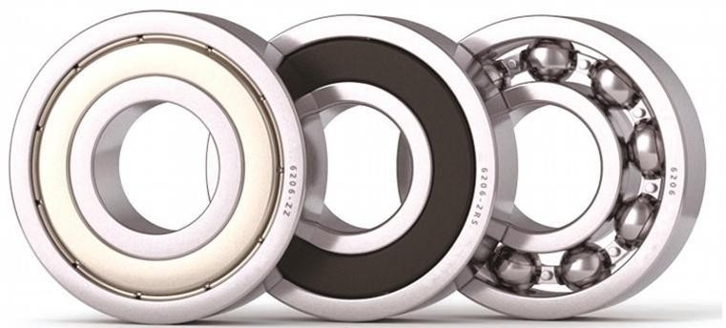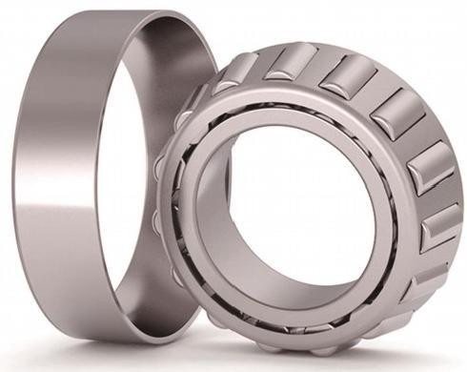

6405-6420 62201-62220 62301-62320

30202-30230

32304-32330

33005-33030

30607-30628

30302-30330

32004-32044

33105-33124

32204-32230

31305-31330

32907-32944

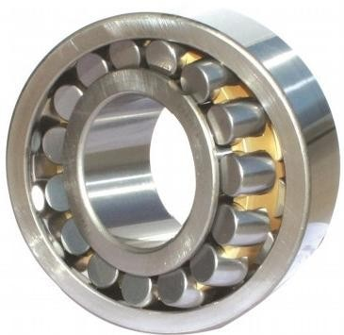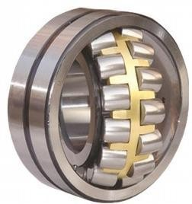

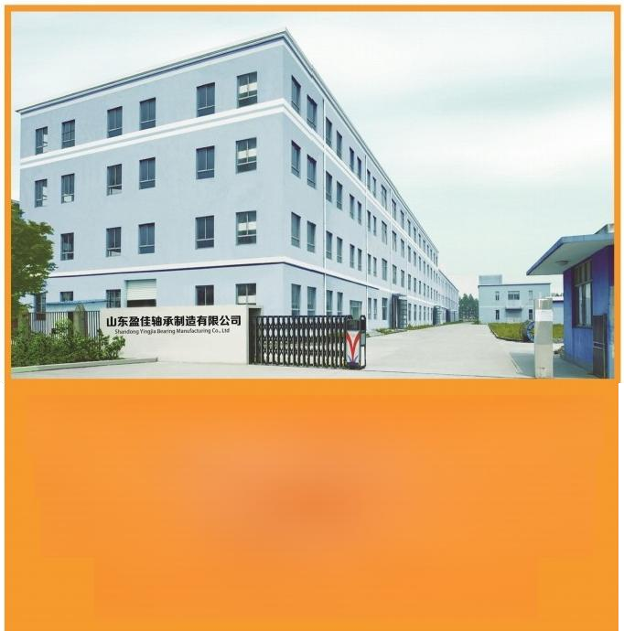

瓦房店有自己的外协加工厂

生产500**GM-2000GM** 外径0-9 类非标轴承

哈尔滨轴承厂/山东分销商

**承揽外贸轴承定单**

**调心滚子轴承具有双列滚子，外圈有1条共用球面滚道，内圈有2条滚道并相对轴承轴**

**线倾斜成一个角度。这种巧妙的构造使它具有自动调心性能，因而不易受轴与轴承箱座角度对误差或轴弯曲的影响，适用于安装误差或轴挠曲而引起角度误差之场合。该轴承除能承受径向负荷外，还能承受双向作用的轴向负荷**。

Self aligning roller bearings have double row rollers,with one shared spherical raceway on the outer ring and two race- ways on the inner ring that are tilted at an angle relative to the bearing axis.This ingenious structure enables it to have automatic centering performance,making it less susceptible to errors or shaft bending caused by the angle between the shaft and the bearing housing.It is suitable for situations where installation errors or shaft bending cause angle errors.

This bearing can not only withstand radial loads,but also axial loads acting in both directions.

**22205CA/W33-22240CA/W33**

**22308CA/W33-22323CA/W33**



**调心滚子轴承**

self-aligning roller bearing

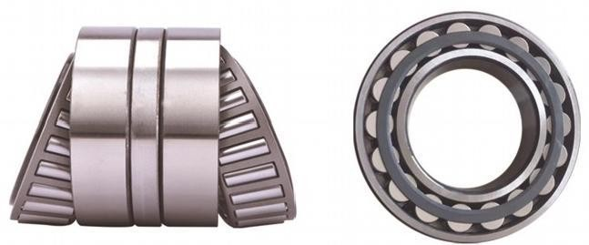

**矿山轴承 E1型**